Find skin cancer: How to perform a skin self-exam

FIND SKIN CANCER: HOW TO PERFORM A SKIN SELF-EXAM
Regularly checking your skin can help catch skin cancer early, when it’s highly treatable. Follow these tips from board-certified dermatologists to check your skin for signs of skin cancer.
Anyone can get skin cancer, regardless of skin color, age, or gender. It is estimated that one in five Americans will develop skin cancer in their lifetime. When caught early, skin cancer is highly treatable.
You can detect skin cancer early by following dermatologists’ tips for checking your skin. Download the AAD's body mole map to document your self-examination, or the How to spot skin cancer infographic and know what to look for when checking your spots.
If you notice a spot that is different from others, or that changes, itches or bleeds, partner with the skin cancer expert, a board-certified dermatologist.
How to perform a skin self-exam
Examine your body in a full-length mirror
Examine your body front and back in a full-length mirror, then look at the right and left sides with your arms raised.
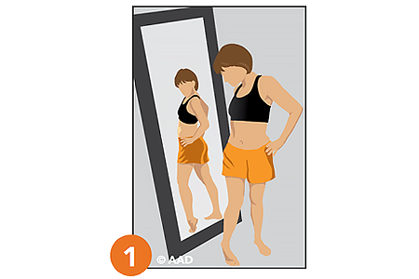
Look at your underarms, forearms, and palms
Bend your elbows and look carefully at your forearms, underarms, fingernails, and palms.
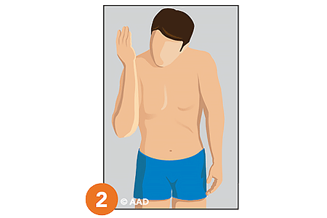
Look at your legs, between toes, and soles of your feet
Look at the backs of your legs and feet, the spaces between your toes, your toenails, and the soles of your feet.
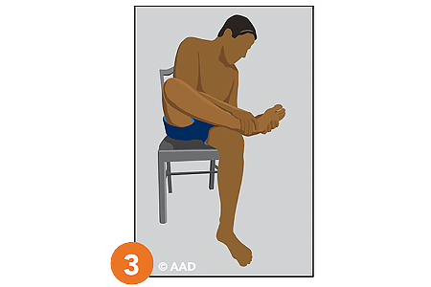
Use a hand mirror to examine your neck and scalp
Examine the back of your neck and scalp with a hand mirror. Part your hair for a closer look at your scalp.
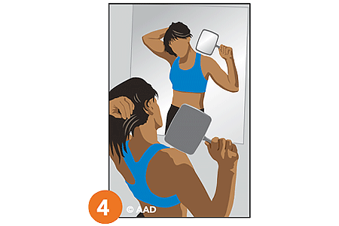
Use a hand mirror to check your back and buttocks
Finally, check your back and buttocks with a hand mirror.
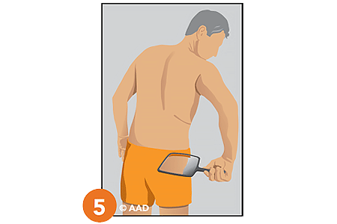
Related AAD resources
- Skin cancer: Learn about symptoms, how skin cancer is diagnosed, and the causes.
- What to look for: ABCDEs of melanoma
- How to spot skin cancer infographic
- Can you spot skin cancer?
- Body mole map

Last updated: 5/15/23

